C12474932 Marcus daly
Algorithm Design Assignment 29/04/2013
Q1:Merge and sort all students who ever attended any IT
a). At first I considered using selection sort, which would find the first unsorted name alphabetically and swap it into the first unsorted position. However, this would be inefficent as it has a worst case scenario of O(n squared), and so it would take a large amount of time to get through everyone in the I.T.s., and if they were already sorted to some degree it would waste time going through them anyway. Realizing how inefficent this method is, I decided to use the merge sorting algorithm. Merge sort is a better choice because its worst case scenario is O(log n), meaning its efficency decreases little with a larger problem. I also considered Insertion sort, but it too lad a poor worst case scenario of O(n squared).

b).The most suitable data structure for this is an array because unlike with stacks and queues, any part of the array can be accessed at any time without the need to allocate memory for every seperate item.

c).How it works:
This method works by first taking all the names from all 3 I.T.s, completely unsorted in an array. It then divides this array up into n(where n is the number of a names) sublists, each consisting of a single element. After this, it begins to rebuild the array: the first two sublists are sorted and combined, as are the third and fourth and so on. The are now half as many sublists. Next, the two first two-element sublists made from the above step combine and sort. This process continues until a single array remains, which is all the names fully sorted.

Inspiration: The alorithm to make this was inspired by
http://www.algorithmist.com/index.php/Merge_sort
edited so that it works for the alphabet

Step by step:
For this example, There are 4 students from each I.T. To be sorted. From DIT are Bob, Harry, Sarah and Claire, from ITT Adrian, Robert, Lisa and Bernie, from ITB are Sean, Andrew, Grace and Ciara.
Dividing
- At the start, the array looks something like this:
|Bob| Harry| Sarah| Claire| Adrian| Robert| Lisa| Bernie| Sean| Andrew| Grace| Ciara|
- Next, Bob is the front so he is assigned the name “low”. Ciara at the back is assigned the name “high”. The “mid” name is assigned by adding the places of low and high and diving the result by 2, rounding down. In this the middle is place number 6, which is robert. “Mid+1 is assigned to the name 1 place before robert, in this case Lisa.
- The array is split in two: one going from to low to mid, then one from mid+1 to high. It now looks like this:
bob|Harry|Sarah|Claire|adrian|robert | |Lisa| Bernie| Sean| Andrew| Grace| Ciara|
- The process restarts because each array is bigger than a single element. Now, the remains the same, but the new high is mid in the first array. Robert is the new high while bob remains the low, and the new mid is sarah. In the other array, the high remains the same as ciara, while the new low is Lisa. The mid is now sean. From this, it will split again. It will look like this:
bob|Harry|Sarah| |Claire|adrian|robert | |Lisa| Bernie| Sean| | Andrew| Grace| Ciara|
- The process continues and continues until all the names are each in a single element array. Now it is time to rebuild and sort.

Rebuilding
- We now have something that looks a little like this:
bob| |Harry| |Sarah| |Claire| |adrian| |robert | |Lisa| |Bernie| |Sean| | Andrew| |Grace| |Ciara|
- Now, we begin sorting them into alphabetical order. We first combine every two elements together, and compare the elements going in, sorting them as we go. For the first 2, B is before H, so bob is in the first position while harry is in second. In the second 2, claire is first due to her name being first.
bob|Harry| |Claire|Sarah| |adrian|robert | |Bernie|Lisa| |Andrew|Sean| |Ciara|Grace|
- This continues again. The first two elements sort themselves, sending an element from both each time:
|Bob|Harry| |Claire|Sarah| -> |Harry| |Claire|Sarah| =>|Bob| -> |Harry| |Sarah| => |Bob|Claire| -> |Sarah| => |Bob|Claire|Harry|
- This sorting continues like this, repeating itself until only a single array remains:
adrian|Andrew|Bernie|bob|Ciara|Claire|Grace|lisa|harry|robert|sarah|Sean|

- Algorithm
Pseudocode:

func mergesort( var a as array of n elements, first = 0, last = n-1, mid = a[(first+last)/2] )

if(first<last)
{
var l1 is an array a[first->a[mid]
var l2 is an array a[mid+1]->a[last]

mergesort(l1)
mergesort(l2)

return merge( l1, l2 )
}
end func

func merge(array a, array b)
array c

while(a and b have elements)
{
if(a[0] comes before b[0])
{
add b[0] to the end of c
remove b[0] from b
}

else
{
add a[0] to the end of c
remove a[0] from a
}
}
while(a has elements but b doesn't)
{
add a[0] to the end of c
remove a[0] from a
}
while(b has elements but a doesn't)
{
add b[0] to the end of c
remove b[0] from b
}
return c
Flowchart:
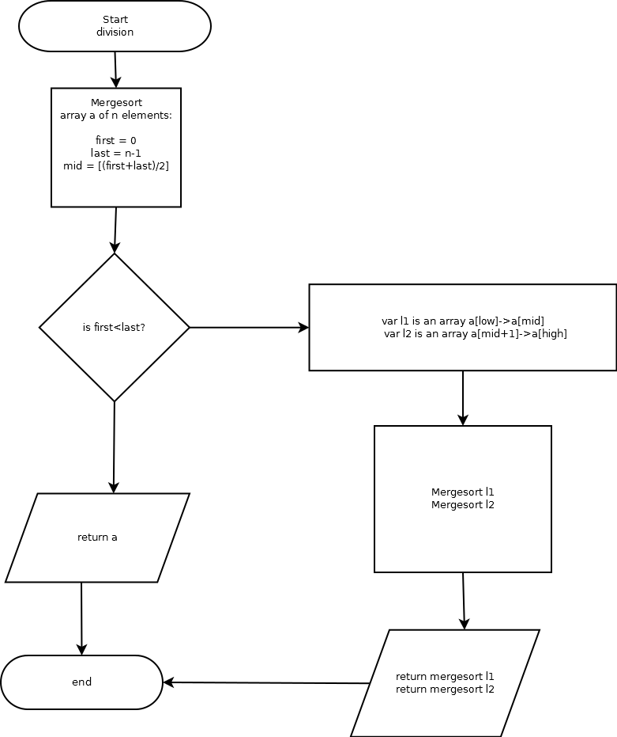

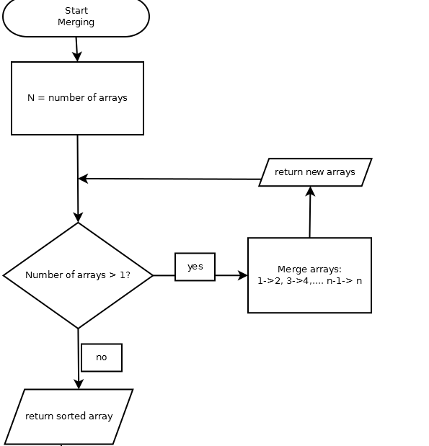

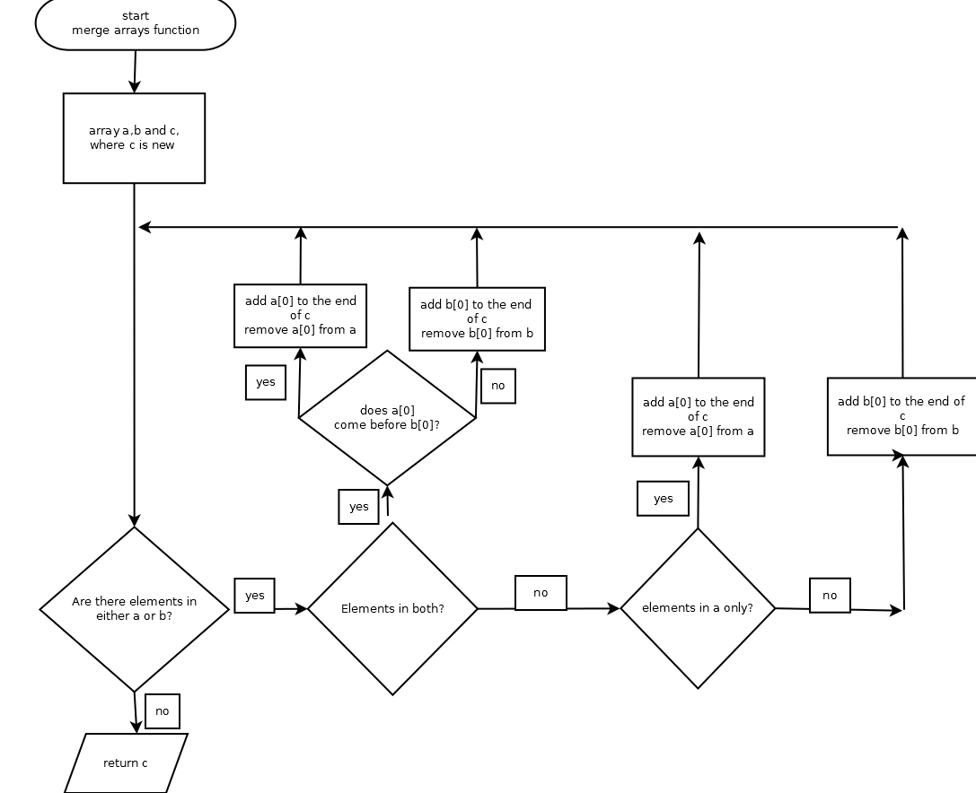

Q2:Search for a student who was in IT tallaght but is now in DIT

a)The two searching algorithms I have considered are linear search and binary search.

How they work:
Linear search is a very basic method of searching for the student as it is a brute force algorithm. It searches through every single student of DIT until it finds a match to the student name from IT tallaght, and then it returns it.

Binary search requires the list to be sorted first, but can be faster than linear. It splits the list of names in two, and checks if the IT students name would be lower than the middle name alphabetically or higher. If its lower, the higher half of the list is scrapped and the search begins again with this half, and if its higher it scraps the lower half and starts again. If the middle is the desired search name it returns it.

Step by step:
Linear
- First, we take the ITT student name and examine the array of DIT student names.
- We now compare the ITT name to the DIT first name, and return them if they're a match.
- If not, we move onto the next element and check again.
- This continues and repeats until either the name is found or the list of names runs out.

Binary:
- First, merge sort the list so it's in alphabetical order. This is important as binary requires the list to be sorted.
- Now that its sorted, find the middle DIT name. If ITT name is this name, return. If not, check to see if the ITT name would be before or after this name. If before, make a new list consisting of all the names before this. If after, make a new list of all the names after.
- Check the middle term of the new list. If its the ITT name, return it, if not check again, creating another new list.
- Continue and repeat until either you run out of elements or you find the name.

Inspiration:
http://www.algorithmist.com/index.php/Binary_Search
http://en.wikipedia.org/wiki/Linear_search

Pseudocode:
Chosen method of searching: Binary

(assuming the names are already sorted and assuming the name is in the array)

for(first = a[0], last = a[n-1], mid = a[n/2], search = IT talaght
name, array of DIT names = a[n] where n is the number of elements)

if(search = mid)
{
return mid
}
else
{
if(search is lower than mid)
{
last = mid - 1
repeat on new array
}
if(search is higher than mid)
{
first = mid +1
repeat on new array
}
}
Flowchart:
